**AP Macro Unit 1b Micro Notes**

**Circular Flow Model**

Microeconomics can be summarized by the relationship & interaction between households, businesses, and government in the Factor/Resource Market and the Product Market

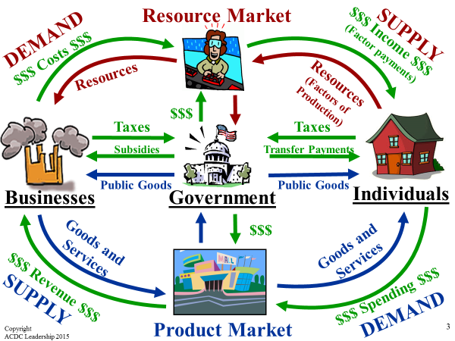

**Demand**

**Demand –** amount of a good or service that a consumer **Desires** and is **Able** **& Willing** to buy at **ALL prices** during a given time period

**Quantity Demanded (Qd) –** amount of a good or service a consumer is willing & able to buy at **EACH PARTICULAR Price** during a given time period

* See the subtle but IMPORTANT difference between Demand & Qd???

**LAW OF DEMAND** states that when the price of a good or service falls, consumers buy more of it (& vice versa)

* Common Sense Right?

**PRICE** = **Qd** or **PRICE** = **Qd**

* **INVERSE RELATIONSHIP** (opposite)between **PRICE & Qd,** so the more something costs the less people will buy (common sense, right?)
* Demand Scheduleshows the **relationship between price & Qd**
* **Demand Curve** shows the same info & the curve **ALWAYS SLOPES DOWNWARD**
* **Movement along the Demand Curve showing a change in Quantity** is caused by a **change in the price** of a product, which changes the Quantity Demanded (Qd) of a product

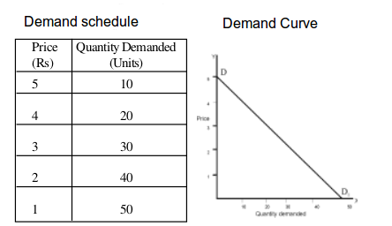

* + **Demand goes Down to the DIRT!**

**Reasons Why Demand Curves Slope Down**

1. **Income Effect** – the change in consumption resulting from a **change in price**, “more bang for your buck”

* Consumers **feel richer when prices drop**, **poorer when prices rise** & both affect the Qd of a product

1. **Substitution Effect** – people will **substitute** a SIMILAR, LOWER-PRICED product for a relatively more expensive one
2. **Law of Diminishing Marginal Utility** – the more of a product you use, the less satisfaction or **utility** (the power to satisfy a want) you’ll get from each unit

* This helps to explain why **demand for a product is not limitless**

**Changes in PRICE don’t shift the curve. It only causes movement along the curve.**

Change in Demand

**Changes in Demand** are reflected as a **shift in the curve**

* Shifts to the **RIGHT** indicate an **INCREASE in demand** (moving away from Zero)
* Shifts to the **LEFT** indicate a **DECREASE in demand** (moving closer to Zero)

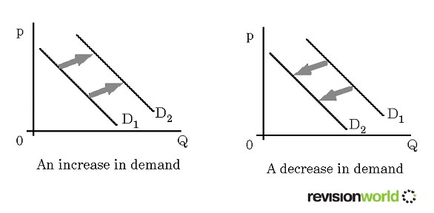

**5 Determinants (“Shifters”) of Demand**

1. **Consumer Income**
2. **Consumer tastes/preferences (Advertisement & Popularity)**
3. **Consumer expectations**
4. **Market size/Population**
5. **Prices of Related Products**

* **Substitute & Complementary goods**

1. A **consumer’s income** affects their demand for goods & services

* Increase in income will cause an increase in consumption
* Decrease in income will cause a decrease in consumption
* **Normal good** – income rises, demand rises (Name Brand Good)
* **Inferior good** – income rises, demand falls (Off Brand or Generic Products)

1. **Tastes/Preferences:** Changes in Popularity of products are seen by the consumer “**dollar vote**”

* Advertising – influence of trends & marketing by firms can affect demand
* Popularity of product decreases, decreases in demand
* Popularity of a product increases, increases in demand

1. **Consumer Expectations** refers to the way people think about the future, as it relates to consumption

* Consumer confidence and expectations of future prices will affect consumption for the present

1. **Market Size:** An increase in the number of consumers can cause an increase or decrease in the demand for products

* Increase in population, increase in demand
* Decrease in population, decrease in demand

1. Demand for goods can be affected by the **price for related goods**:

* **Complements** – demand of one good increases as a result of the purchase of another good
* **Substitutes** – demand for one good decreases because another good is used in its place

**What never changes Demand? ____________**

**Elasticity of Demand** is the degree to which changes in a good’s price affect the quantity demanded (Qd)

* **Elastic Demand** exists when a **small change in a good’s price** causes a **MAJOR, OPPOSITE change in Qd**
  + small price increase = a LARGE change in Qd
  + Elastic Demand follows the regular rules of the Law of Demand
* **Inelastic Demand** – demand for a good or service are **unaffected** when the price of that good or service changes

**Determinants of Elasticity**

1. **Necessities v. Luxuries:** Need v. Want

* Medicine such as insulin for diabetics is inelastic because it’s life or death

1. **Existence of Substitutes**
2. **Proportion of Income**: % of a person’s total budget used to buy the good

* That’s why cheap items like salt, rubber bands, etc. are inelastic

1. **Time allowed to adjust** for the price change

* More time allowed = more elasticity

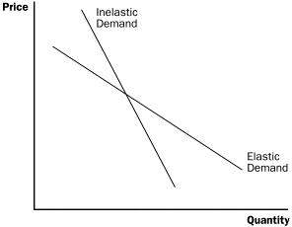

* Gasoline has Relatively Inelastic Demand
* Insulin has Perfectly Inelastic Demand

P P

D D

Q (Insulin) Q (Gas)

Total Revenue (TR) and Elasticity of Demand

**PRICE** = **TR** then Demand is Inelastic

**PRICE = TR** then Demand is Elastic

(vice versa)

**Supply** is the quantity of goods & services that producers (firms/businesses) are **WILLING** to offer at **ALL** possible prices during a given time period

**Quantity Supplied (Qs)** is the amount of a good or service that a producer is willing to sell at **EACH PARTICULAR PRICE**

**LAW OF SUPPLY** – states that producers **supply more goods & services** when they can **sell them at higher prices** and **fewer goods & services** when they must **sell them at lower prices**

**PRICE = Qs or PRICE = Qs**

* Notice the **DIRECT (Positive) relationship** between price and Qs
* Producers’ actions are based primarily on the pursuit of ***PROFITS!!***

***Those Greedy Capitalists!***

**Profit = Total Revenue - Total Costs**

* **Supply schedule** – table that shows how much a good or service producers in a market are willing to offer for sale at each price
* **Supply curve** – shows the data from the supply schedule on a graph
* **Supply curve** **ALWAYS slopes** **UPWARD** reflecting Law of Supply

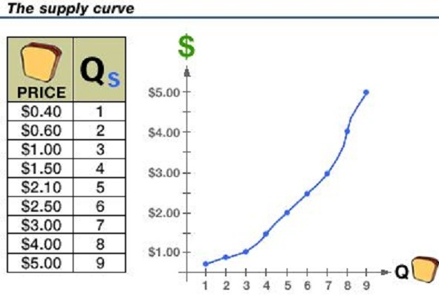

* + **Supply to the SKY!!!**

**A change in price causes MOVEMENT along the Supply Curve; not a shift in Supply**

**Changes in Supply are reflected by a Rightward (Increase) or Leftward (Decrease) shift in the Supply Curve**

**S2**

Price

**S S1**

Quantity

**S is the original Supply Curve**

**S1 shows an increase (shift right) in supply**

**S2 shows a decrease (shift left) in supply**

**6 Determinants (“Shifters”) of Supply**

1. Price of Resources/Input Costs
2. Technology
3. Government Tools: Taxes & Subsidies
4. Number of Sellers/Competition
5. Business Expectations
6. Opportunity Cost of Alternative Production
7. **Prices of Resources/Input Costs**

* **Input Costs** – the cost of producing the good increases/decreases based on the materials necessary to produce (inputs)
  + Inputs necessary to produce are land, labor, capital (productive resources)
  + Energy costs (oil) are a key factor in supply

1. **Technology/Productivity**

* Technological innovations **improve productivity** & **increases ability to supply**
* **Productivity** – amount of goods & services produced per unit of input

1. **Government Tools:**

* **Taxes/Regulations (Negative Impact)**
* **Subsidies (Positive Effect)**
  + **Subsidy** – Gov’t payment that helps cover the cost of an economic activity that benefits the public
* Energy Industries & Agricultural Products receive Gov’t subsidies
  + Subsidies motivate firms to produce because they are guaranteed revenue from the government
* shifts Supply Curve to the RIGHT

1. **Competition/Number of Sellers in Market**

* Number of sellers – an increase/decrease in the number of sellers will cause an increase or decrease in the supply of goods & services

1. **Business/Producer Expectations**

* Expectations – suppliers’ future expectations of the price of products will determine how much they produce/sell presently and business inventory will reflect how they view the state of the economy in the future (**business cycle & interest rates**)
* Suppliers will build up their inventory if they feel the economy will be strong showing **economic growth,** but reduce inventory if they feel an economic contraction is coming due to a **recession**

1. **Opportunity cost of alternative production** – if businesses can make more profits producing an alternative product, then they will

**Make sure you understand the difference between a Change in Quantity caused by a change in Price and a Change in Supply & Demand caused by one of the non-price “Shifters”**

* **Elasticity of Supply** is the degree to which price changes affect the Qs
* Elastic Supply exists when products can be made (1) quickly, (2) inexpensively, (3) using a few readily available resources
* Inelastic Supply exists when a **change in a good’s price** has **little** impact on the Qs, and occurs when a product (1) requires a great deal of time to produce, (2) is expensive to produce, (3) and resources are not readily available
  + Ex: islands in the Bahamas or moon rocks

**What never changes Supply? _____________**

Supply & Demand are put together to determine **equilibrium price &** **equilibrium quantity**

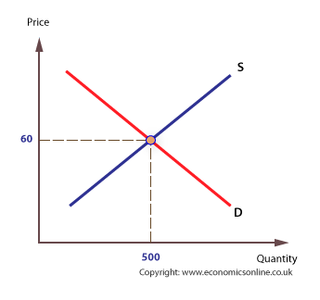

**Market Equilibrium** – the point of balance where Demand & Supply come together (intersect), establishing the **market clearing price (Pe)** where **Qd = Qs**

Shifting Supply and Demand Curves

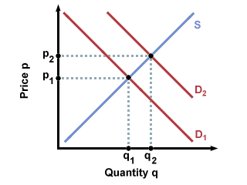

Demand shifts Right (Increase), causing Quantity to Increase and Price to Increase

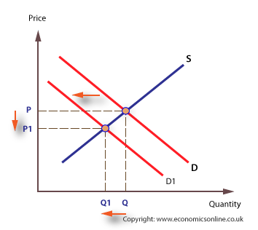

Demand shifts Left (Decrease), causing Quantity to Decrease and Price to Decrease

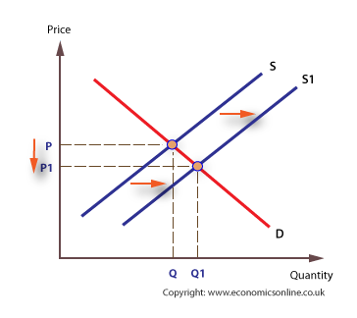

Supply shifts to the Right (Increase), causing Quantity to Increase and Price to Decrease

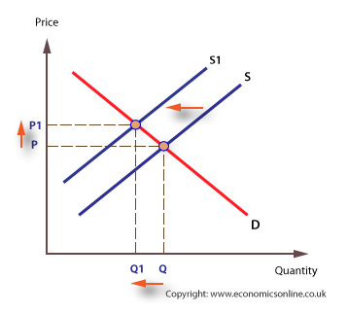

Supply shifts to the Left (Decrease), causing Quantity to Decrease and Price to Increase

“Double Shifter Rule”

If TWO curves shift at the same time, **EITHER price or quantity** will be **indeterminate**

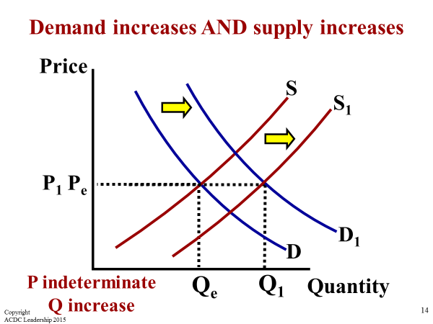

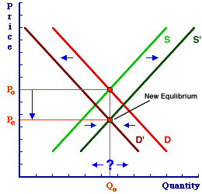

**Price Decreases & Quantity is Indeterminate**

**Disequilibrium** – occurs when the quantity supplied is not equal to the quantity demanded

* **Surplus** – result of **Qs > Qd,** usually because **prices are too high**
* **Shortage** – result of **Qd > Qs**, usually because **prices are too low**

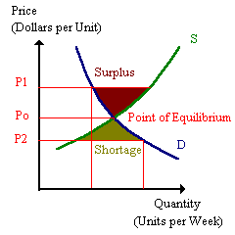

When the Free Market experiences disequilibrium (**Surplus** or **Shortage**), a new equilibrium clearing price must be established by **producers decreasing or increasing the price & production**

* Remember **Adam Smith’s Invisible Hand** and **Laws of Supply & Demand?**

Gov’t Intervention and **PRICE CONTROLS**

1. **Price Ceilings** – Gov’t imposed **maximum price that can be legally charged** for a good/service

* **Price ceilings always cause a shortage in the market** (Remember this!!!)
  + New York introduced rent control in the early 1940s as a way to provide affordable housing; the result led to massive apartment shortages

1. **Price Floors** – Gov’t imposed, **minimum price that can be legally charged** for a good or service

* **Price floors always cause a surplus in the market** (Got that???)
  + **Minimum wage is a price floor** that causes a surplus of workers & rising unemployment

Price

**Surplus (Qs > Qd) S**

**Price Floor - - - - - - - - - - - - - - - - - - - - - - -**

Pe - - - - - - - - - - - - - - - - - - **Equilibrium**

**Price Ceiling - - - - - - - - - -- - - - - - - - - - - -**

**D**

**Shortage (Qd > Qs)**

Qe Quantity

**Price Floor is set at the TOP of the graph because you can’t go below the set price, causing a Surplus. Think about the floor that you walk on; you can’t go below, but you can jump up or climb higher**

**Price Ceiling is set at the BOTTOM of the graph because you can’t go higher than the ceiling. Think of a balloon that you let go inside the room. The balloon wants to float higher in the sky to find equilibrium, but the ceiling prevents it from going any higher causing a Shortage**

**4 Types of Market Structures**

1. **Perfect (Pure) Competition** is the simplest & most competitive market structure; a large number of firms producing identical product**s**

4 characteristics:

1. **Identical Products**
2. Many buyers and sellers (most competitive)
3. No barriers to entry
4. Market Price is controlled by Supply & Demand (Invisible Hand)

* **Firms are “Price Takers”**
* Ex: fresh produce (fruits & vegetables)

1. **Monopolistic Competition** – many companies (“little monopolies”) selling similar products

* **Don’t confuse monopolistic competition with a monopoly**

4 Characteristics:

1. **Similar Products** (not identical)
2. Many buyer and sellers
3. Low barrier to entry
4. Slight control over price

* **Brand Differentiation** is the main difference between perfect & monopolistic competition
* Examples include fast food restaurant chains, clothing retailers, etc.

1. **Oligopoly** – a market structure in which a **few large firms dominate a market**; a few of the largest firms **produce at least 70-80% of the output**.

4 Characteristics:

1. Identical/slightly different products
2. **A few firms (2-3)**
3. High Barriers to Entry
4. Market Power over the price

* Examples: Automobile industry, commercial airlines, oil cartels, web browsers, smartphones, etc.
* **Collusion** – businesses work together to agree to **price fix**, which **damages the free market** (sell at the same or very similar prices)
* **Cartel** – a formal organization of producers that **fix prices and control supply**
  + **OPEC**: Organization of Petroleum Exporting Countries

**Most all products sold in US come from either monopolistic competition or oligopolies.** Monopolistic competition and oligopolies try to **avoid PRICE WARS** (lowering prices to attract consumers) between each other, so these market structures use **non-price competition techniques** to encourage consumers to buy their products or use their services instead of the competition

* Ex: Free shipping, Coupons, etc.

1. **Monopoly** – when **one single company controls the market** of a good/service and can **effectively dictate prices**

4 Characteristics:

1. No substitutes
2. **One Seller (least competitive)**
3. Complete Barrier to Entry
4. Total Market Power (“**Price Makers**”)

* Ex: Standard Oil in late 1800s

**Natural Monopolies** consist of utility companies (power, water, cable, etc.) and are allowed to exist by the government because they offer a product/service at a lower cost than if several competitors were to compete against one another

* Gov’t still regulates natural monopolies to prevent the monopoly from raising prices too high for customers

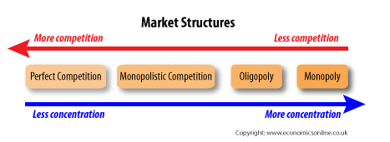

**Business Organizations**

**Business organization** (**firm**) – establishment formed to bring goods & services to consumers in the market

* **Liability** – legal obligation to pay debts/injury settlements incurred by the business

1. **Sole proprietorship –** a business owned by one person (most common; about 75%)

* **Advantages**
* Easy to start up, manage & liquidate
* You keep ALL the PROFITS
* no separate business taxes
* **Disadvantages**
* **UNLIMITED LIABILITY**
* **Difficult to raise financial capital**
* Hard to attract qualified employees
* Limited life of company

1. **Partnership –** business owned by 2 or more people (least common; about 5%)

* General Partnership – each partner is responsible for everything
* Limited Partnership – some partners are not “active”
* **Advantages**
* Easy to start & manage (partners bring different strengths & expertise)
* Easier to raise financial capital & more efficient (specialization)
* Easier to attract qualified employees
* **Disadvantages**
* Possible conflict between partners
* Limited life of business

1. **Corporation** – **business organization owned by individual shareholders, each of whom faces limited liability for the firms debt**

* Account for 20% of all businesses, but 90% of all products sold
* Considered a separate legal entity
* Corporations issue **STOCK** (Shares) to investors (**Shareholders**)
* Shareholders can receive **dividends** (profits from stock) & are the OWNERS of the business, but face no liability for the firm’s obligations
  + Common stock – get one vote per share when electing the Board of Directors
  + Preferred stock – non-voting shares but you get any dividends before common stock holders
* If own the majority (51%) of stock, then you control the company
* **Advantages**
* **Easy to raise financial capital by selling stock or issuing bonds**
* Ability **to offer higher salaries & greater benefits** allows corporations to recruit the best, brightest, most talented, ambitious, and professional employees & managers
* **Limited liability to shareholders**
* **Unlimited life** (transfer ownership by selling stock)
* **Disadvantages**
* Can be difficult and expensive to get a **Charter** to start corporation
* Shareholders usually have little input in the corporation
* **Double Taxation** of profits
* **More Gov’t Regulation**