Name: ___________________________________ Period: _____ Date: ___________

**UNIT 2 TEST STUDY GUIDE**

***Directions:*** *Please complete the following study guide and use it to prepare for your   
   
 first summative test grade. The test will be on _______________________.*

1. Where is the oldest ocean floor found in relation to the Mid-Ocean Ridge? **The furthest away from the ridge**
2. Why did Alfred Wegener’s Theory of **Continental Drift** receive ridicule from the scientific community? **Because he could not explain the forces that pushed or pulled the landmass**
3. When fossils of fish are found in the desert, you can infer the area was once: **covered in water**
4. When fossils of ferns are found in ice cold climates, you can infer the area was once: **a warm climate**
5. What currents in the Earth’s mantle cause plate movement? **Convection** / Conduction
6. What are the three types of plate boundaries and how do they move (draw a diagram)?
   1. 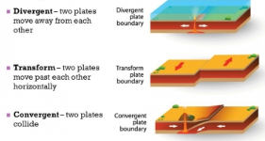**Transform (sliding)**
   2. **Divergent (pulling apart)**
   3. **Convergent (colliding)**
7. What is a fault line? **a break or fracture in the ground that occurs when the Earth’s tectonic plates move or shift and are areas where earthquakes are likely.**  
   Can you name a famous one out in California? **San Andreas**
8. What type of tectonic plates might form a large mountain range? (see #5) **Convergent**
9. What type of tectonic plates might cause an earthquake to occur? (see #5) **Transform**
10. Describe the Theory of Plate Tectonics. **The theory proposes that all continents were once connected and have “drifted” to their current location over time.**
11. Earthquakes and volcanoes are not randomly distributed on Earth but occur in concentrated areas that match up with **Tectonic Plate** boundaries.
12. How are mid-ocean ridges formed? **Mid-ocean ridges are underwater mountainous regions formed by the separation of tectonic plates.**
13. Draw and explain what a subduction zone is.

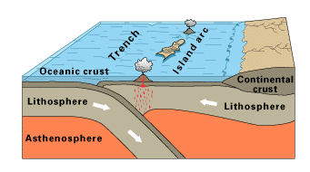

1. What results in seafloor spreading? **The plates involved grow in size and the ocean floor extends.**
2. What is a volcanic hot spot? **A volcanic hot spot is a place in the mantle where rock melts to generate magma, Hawaii has a hotspot.**
3. How do volcanos form and where do you find them? **Volcanoes at boundaries such as (convergent, divergent) and are concentrated at plate boundaries**
4. The supercontinent was called **Pangaea**. It was formed in the Paleozoic Era.
5. What three pieces of evidence did Wegener use to support his Theory of Continental Drift?
   1. **Fossil evidence**
   2. **The continents fit together like pieces of a puzzle**
   3. **Glaciers traces found in warmer climates**
6. The layer of the Earth known as the **lithosphere** is broken up into several tectonic **plates** that “move and float very slowly”.