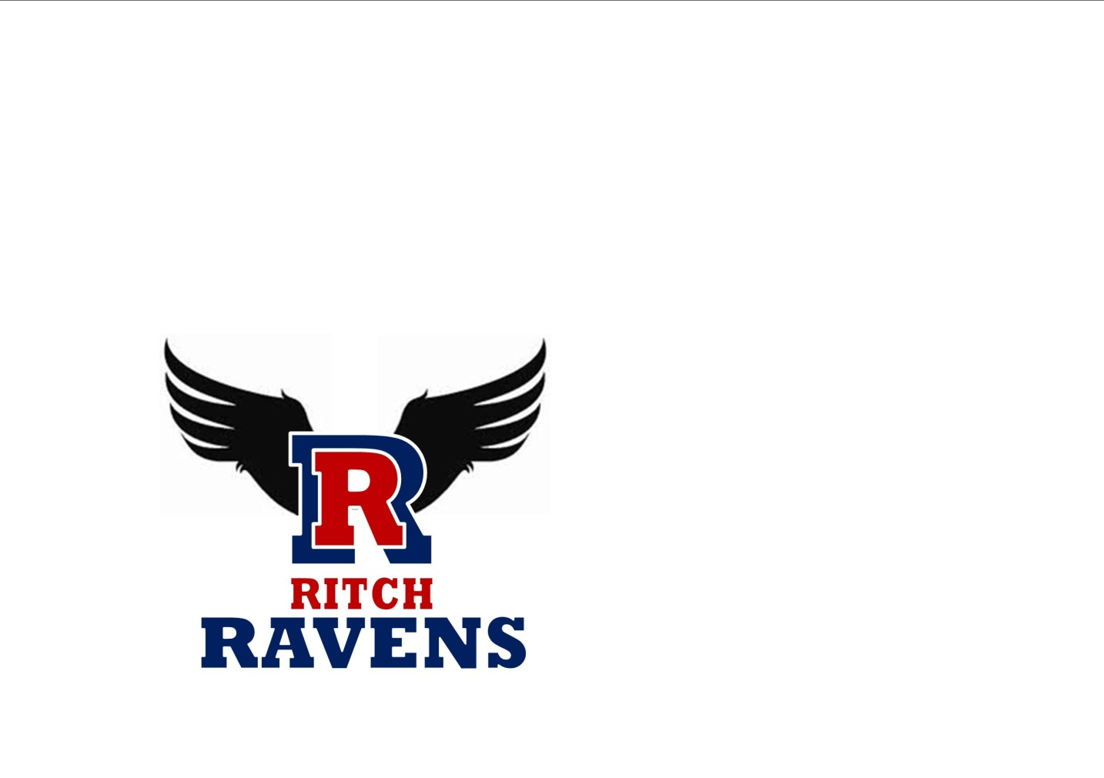**P.B. Ritch Middle School**

**Local School Council Meeting Minutes**

**February 1, 2024**

|  |  |  |
| --- | --- | --- |
| **Inv** | **Att** | **Name** |
| Council Members | | |
| X | X | Christine M. Carson – Principal |
| X |  | Donitra Smith – Chairperson |
|  |  | TBD – Vice Chairperson |
| X | X | Aimee Buchanan – Secretary |
| X | X | Dennis Casey |
| X | X | Scot Gutierrez |
| X | X | Tamika McNeal (w/daughter Kendall) |
| Other | | |
|  |  |  |

**1. 2023-2024 School Improvement Initiatives**

* School Improvement Plan at a Glance (Handout provided)
* RMS showed tremendous gains on the District Math Growth Measure compared to all PCSD Middle Schools (6th grade – 1st place, 7th grade – 4th place, 8th grade – 2nd place)

**2. Parent & Community Information Night on February 12, 2024 at 6-8pm**

* District event for all PCSD middle schools hosted at PBR with sessions on various topics. (Handout provided)
* Childcare for K-5th grade will be provided in the gym with procedures for check-in and check-out

**3. 2023-2024 RMS Calendar**

* Remaining events listed for the year:
  + 2/1 Family Fun Night at 6:30pm
  + 4/11 Raven Ensembles Performance/PTSA at 6:30pm
  + 4/16 STEM/Curriculum Night at 6:30pm-8:00pm
  + 5/7 Chorus Concert at 6:30pm
  + 5/9 Band Concert at 6:30pm

**4. Comments/Notes**

* Alanna Bowie has moved. The position of Vice Chairperson is open.
* 8th Grader Sumaya Bell, District Spelling Bee Champion for 2024. Previously 2023 District Spelling Bee Champion as a 7th Grader. Will be competing at Region 1 Championship on February 24th.
* PBR has benefited as a Title Support (not Title I) school with smaller class sizes in math.
* Role of the School Council (Handout provided)
  + Quarter vs. Semester Grades provided by printout to parents?
  + Topics we would like to address in future meetings? Example of previous issue discussed was uniforms.
* Dr. Carson to address addition of naming conventions to standardize use in CANVAS
* Future meeting/invitation possible to see classrooms including Ms. Nunn’s (PBR TOY) special ed. Ms. Nunn is in the running for GaDOE’s Teacher of the Year.

**5. Future Agenda Items**

* TBD

**Next Meeting Time & Location:**

Thursday March 14, 2024 at 4:00pm

Please send corrections, additions, questions via e-mail to [lovethebunnies@gmail.com](mailto:lovethebunnies@gmail.com).