**AP Macro Unit 1 Basic Econ Concepts Notes**

**Economics** is the science of **scarcity** and the study of **choices**

* Limited resources & unlimited human wants
* Study of how individuals and societies deal with **Scarcity**

***Certeris Paribus –*** allother things being equal

**Scarcity**- we have unlimited wants but limited resources.

* Since we are unable to have everything we desire, we must make choices on how we will use our scarce resources.
* In order to be considered scarce, a good or service must be (1) limited, (2) desirable, (3) have a cost
* In economics we will study the choices of individuals, firms, and governments.

MICROeconomics - study of small economic units such as individuals, firms, and industries (ex: supply and demand in specific markets, production costs, labor markets, etc.)

MACROeconomics - study of the large economy as a whole or economic aggregates (ex: economic growth, government spending, inflation, unemployment, international trade)

Positive v. Normative Economics

Positive Statements- Based on facts. Avoids value judgements (what is).

Normative Statements- Includes value judgements (what ought to be).

**5 Key Assumptions**

1. Society has unlimited wants and limited resources (**scarcity**).
2. Due to scarcity, choices must be made. **Every choice has a cost** (a trade-off).
3. Everyone’s goal is to make choices that maximize their satisfaction. **Everyone acts in their own “self-interest.”**
4. Everyone makes decisions by **comparing the marginal costs and marginal benefits of every choice.**
5. Real-life situations can be explained and analyzed through simplified models and **graphs**.

**Marginal analysis** (aka: “thinking on the margin”) making decisions based on increments

* In economics the term **marginal** = additional (1 more unit)
* You will continue to do something as long as the **marginal benefit** is greater than the **marginal cost**
* MB > MC = good decision
* MC > MB = bad decision/not worth it

Trade-offs and Opportunity Cost

All decisions involve **trade-offs**

* **Trade-offs -** ALL the alternatives that we give up when we make a choice
  + Ex: If you choose to study for an economics test, then you give up a chance to go to the movies or read a book (trade-offs)
* **Opportunity cost-** most desirable alternative given up when you make a choice.
  + #1 trade-off you give up

“THERE IS NO SUCH THING AS A FREE LUNCH!” (**TINSTAAFL**)

**There’s ALWAYS a COST!**

Economic Terminology **(Must Know!)**

* **Utility** = Satisfaction
* **Marginal** = Additional
* **Allocate** = Distribute

What’s the price? vs. How much does that cost?

* **Price** = Amount buyer (or consumer) pays
* **Cost** = Amount seller pays to produce a good
* **Investment =** the money spent by **BUSINESSES** to improve their production
  + Ex: $1 million investment in new factories or capital equipment
  + In economics, Investment **ALWAYS** refers to businesses purchasing CAPITL GOODS

**Goods v. Services**

**Goods -** physical objects that satisfy needs and wants

* **Consumer Goods -** created for direct consumption and individual’s utility
  + Ex: pizza, tennis shoes, car, etc.
* **Capital Goods -** created for indirect consumption(ex: oven, knives, bulldozer)
  + **Goods used to make consumer goods**; without capital goods there will be no consumer goods

**Services -** actions or activities that one person performs for another (teaching, cleaning, cooking)

**Factors of Production/Productive Resources**

ALL **resources** can be classified as one of the following four factors of production:

1. **Land -**All **natural resources** that are used to produce goods and services. (Ex: water, sun, plants, animals)
2. **Labor** -Any effort a person devotes to a task for which that person is paid; **workforce** (Ex: manual laborers, doctors, teachers, waiters, etc.)
3. **Capital -** 
   * **Physical Capital -** Any human-made resource that is used to create other goods and services ( Ex: tools, tractors, machinery, buildings, factories, etc.)
   * **Human Capital -** Any skills or knowledge gained by a worker through education and experience
4. **Entrepreneurship -** ambitious leaders that combine the other factors of production to create goods and services.

* Ex: Henry Ford, Bill Gates, Inventors, Store Owners, etc.
* Entrepreneurs take the initiative, innovate, and are “**risk-takers**” in order to make a **PROFIT**

**Profit = Revenue – Costs**

**Economic Systems**

Every society must answer the 3 basic economic questions?

1. **What** goods and services should be produced?
2. **How** should these goods and services be produced?
3. **Who** consumes these goods and services?

The way these questions are answered determines the economic system

**Economic system** is the method used by a society to produce and distribute/allocate goods and services.

1. **Centrally Planned (Command) Economy-**

**the government (Communism)…**

* owns all the resources
* answers the 3 economic questions

Ex: Cuba, China, North Korea, former USSR

Why do centrally planned economies face problems of poor-quality goods, shortages, and unhappy citizens?

* **Little incentive to work** **harder** and central planners have a hard time predicting preferences

Advantages of Communism:

* Low unemployment-everyone has a job
* Great Job Security-the government doesn’t go out of business
* Equal incomes means no extremely poor people
* Free Health Care

Disadvantages of Communism:

* No incentive to work harder
* No incentive to innovate or come up with good ideas
* No Competition keeps quality of goods poor.
* Corrupt leaders
* Few individual freedoms
* **The End Result: There is a shortage of goods that consumers want, produced at the highest prices and the lowest quality**

1. **Free Market System (aka: Capitalism)**

* Little government involvement in the economy. (***Laissez Faire*** = Let it be)
* Individuals OWN resources and answer the three economic questions.
* The opportunity to make PROFIT gives people INCENTIVE to produce quality items efficiently.
* Wide variety of goods available to consumers.
* Competition and Self-Interest work together to regulate the economy (keep prices down and quality up).
* **The End Result: Most efficient production of the goods that consumers want, produced at the lowest prices and the highest quality.**

**Adam Smith’s Invisible Hand Theory:** The concept that society’s goals will be met as individuals seek their own self-interest. Competition and self-interest act as an invisible hand that regulates the free market.

1. **Mixed Economies -** A system with free markets but also some government intervention.

* Almost all countries, including the US, have mixed economies

**Productivity creates WEALTH!**

Countries with free markets, property rights, and The Rule of Law, have historically seen greater economic growth because they are more productive

**7 Economic & Social Goals**

1. **Economic Freedom** – freedom to buy or sell what we want, make choices with little interference by the government
2. **Economic Efficiency/Innovation** – making the most of scarce resources, using your resources wisely and productively by improving upon existing technology
3. **Economic Growth** – improving the economy from year to year, improving people’s standard of living
4. **Full Employment** – highest amount of the labor force that could be employed within an economy at any given time (95% employment rate or better)
5. **Economic Security** – government will provide a safety net in times of economic downturns
6. **Price Stability** – knowing that goods & services will consistently be available at stable prices (Beware Inflation!!!)
7. **Economic Equity** – Fair pay for equal work; being paid according to your skill level & not discriminating based on race/ethnicity, gender, age, religion, etc.

**Production Possibilities Curve (Frontier)**

A **production possibilities curve** (PPC) is a model that shows alternative ways that an economy can use its scarce resources

* This model graphically demonstrates **scarcity, trade-offs, opportunity costs, and efficiency**

4 Assumptions of the PPC

1. Only two goods can be produced
2. Full employment of resources
3. Fixed Resources (***Ceteris Paribus*** *–* all other things being equal)
4. Fixed Technology

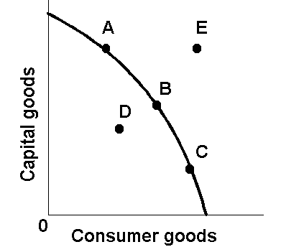

PPC shows that **nothing is free** & **everything has an opportunity cost**, if society wants more of one thing it must give up something in return

* **Efficiency** – condition in which economic resources are being used to produce the maximum amount of goods & services (**on the curve – Full Employment**)
* **Underutilization** – condition in which economic resources aren’t being used to their full potential (**inefficient; inside the curve - Recession)**
* **Unattainable** – production cannot be attainable for an extended period of time with current resources and technology **(outside the curve/frontier)**
* Points **A, B, C** are all efficient, operating **at Full Employment** (on the curve)
* Point **D** is inefficient, showing the economy is in a **Recession** (inside line)
* Point **E** is unattainable for long periods of time (**outside the line**) and represents an economy experiencing an **Inflationary Gap**

**Law of increasing opportunity costs** states that as production switches from one product to another, increasingly more resources are needed to increase the production of the second product, which causes opportunity cost to rise

* **PPC has a concave (bowed-out) curve**

Basketballs

8

6

4

2

0

1. 2 3 4 5 6

Whoopie Cushions

**Constant Opportunity Cost** - Resources are easily adaptable for producing either good.

Result is a straight line PPC (not common)

* **PPC has a straight line**

Corn

4

3 - -

2 - - - - -

1 - - - - - - - -

1. 2 3 Wheat

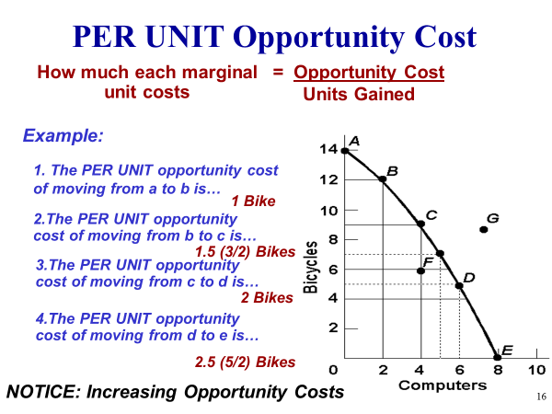

**2 Types of Efficiency**

Productive Efficiency - products are being produced in the least costly way.

* **Any point ON the Production Possibilities Curve**

Allocative Efficiency - products being produced are the ones most desired by society.

* **This *optimal* point on the PPC depends on the desires of society.**

3 Changes can Cause the PPC to Shift Right

**PPC can shift outward to the right showing long term economic growth**:

1. **Increase productive resources** (quantity or quality)

* F.O.P: land, labor, **capital** (physical & **human capital**), entrepreneurship

1. **New technology** = efficiency & productivity
2. **International Trade\*** (based on Comparative Advantage)

Guns

A B Economic Growth

Butter

**Countries that produce more capital goods will have more growth in the future because capital goods produce other goods while consumer goods are made to increase individual’s utility (satisfaction)**

Machines

X

A

B

Pizzas

Point A would be more beneficial for this society to experience economic growth in the long-run and extend the PPC to Point X because its producing more machines (capital goods) and less pizzas (consumer goods).

Because each nation has certain productive resources & cannot produce everything it wants, individuals, businesses, & nations must decide what goods & services to focus on

* **Specialization** – a situation that occurs when individuals or businesses produce a narrow range of products to **maximize resources,** increase **productivity,** & make a **profit**
* **Economic interdependence** – a situation in which producers in one nation depend on others to provide goods & services they don’t produce (opposite of **isolationism)**

Absolute v. Comparative Advantage

**Absolute Advantage** - the producer that can **produce the most output** OR **requires the least amount of inputs** (resources)

* Ex: Papa John has an absolute advantage in pizzas because he can produce 100 and Ronald can only make 20.

**Comparative Advantage** - The producer with the **lowest opportunity cost**

* Ex: Ronald has a comparative advantage in burgers because he has a lowest PER UNIT opportunity cost.

Countries should trade if they have a relatively lower opportunity cost

* They should specialize in the good that is “cheaper” for them to produce
* **Law of comparative advantage** – a nation or person is better off when it produces goods and services for which it has a comparative advantage

Absolute/Comparative Advantage Rules

* **Input** vs. **Output** Problems
* **Output** problems state that you get a certain amount of a product out of a given number of inputs (resources)
  + **Ex:** miles per gallon of gas, pieces of gum per dollar
* **Input** problems state that it takes a certain amount of inputs (resources) to get a given output (product)
  + **Ex:** hours to paint the house, apples to make a pie

**Absolute Advantage**

* For **Output** problems, you look to see who (nation, business, individual) can **produce the most** outputs with the same resources
* For **Input** problems, you look at who uses the **least amount** of inputs to get the output

**Comparative Advantage**

* For **Output** problems, it’s **Other Over**
  + Hint: **O**utput = **OOO** (Triple O’s!)
* For **Input** problems, it’s **Other Under**
* You look for the **smallest number**, which signifies the **least Opportunity Cost**
* There can never be a Comparative Advantage **in both products**

Product from 1 ton of peanuts **(Output)**

|  |  |  |
| --- | --- | --- |
|  | Peanut Butter | Peanut Oil |
| Company A | 40 | 30 |
| Company B | 60 | 20 |

Company A has the **Absolute Advantage (AA)** in producing Peanut Oil, and Company B has the **AA** in Peanut Butter

Company B has the **Comparative Advantage (CA)** in Peanut Butter (20/60 = 1/3 is less than 30/40 = 3/4) and Company A has the **CA** in Peanut Oil (40/30 = 4/3 is less than 60/20 = 3)

* Company A: 1 PB =3/4 PO
* Company B: **1 PB = 1/3 PO**

Company B has lowest Opportunity Cost and should only produce peanut butter with the peanuts

* Company A: **1 PO = 4/3 PB**
* Company B: 1 PO = 3 PB

Company A has lowest Opportunity Cost and should only produce peanut oil with the peanuts

Apples to make one **(Input)**

|  |  |  |
| --- | --- | --- |
|  | Pie | Juice |
| Glenda | 5 | 3 |
| David | 6 | 3 |

Glenda has an **AA** in Pies, and neither have an **AA** in Juice (same # of inputs)

Glenda has **CA** in Pies (5/3 = 1 2/3 is less than 6/3 = 2), and David has **CA** in Juice (3/6 = ½ is less than 3/5)

* **Glenda: 1 Pie = 1 2/3 Juice**
* David: 1 Pie = 2 Juice

Glenda has the lowest opportunity cost and should only produce Pies with her apples

* Glenda: 1 Juice = 3/5 Pie
* **David: 1 Juice = ½ Pie**

David has the lowest opportunity cost and should only produce Juice with his apples

Both countries can benefit from trade if they each have relatively lower opportunity costs.

**Terms of Trade** - The agreed upon conditions that would benefit both countries

* Ex: Trade 1 ton of wheat for 1.5 tons of sugar

**Circular Flow Model**

Microeconomics can be summarized by the relationship & interaction between households, businesses, and government in the Factor/Resource Market and the Product Market

**Product Market** - “place” where **goods and services** produced by businesses are sold to households

**Resource (Factor) Market** - “place” where **resources** (land, labor, capital, and entrepreneurship) are sold to businesses by individuals/households

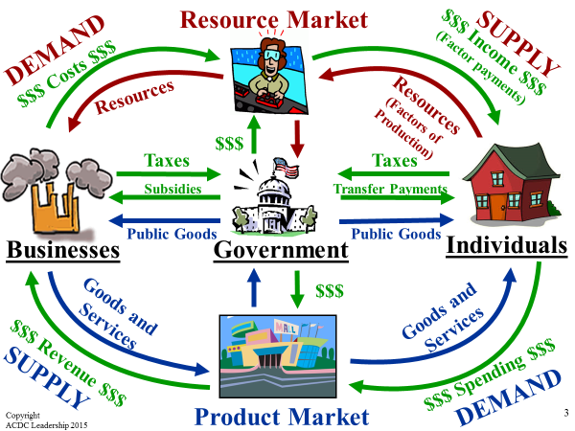

Circular Flow Key Vocabulary

**Private Sector**- Part of the economy that is run by individuals and businesses

**Public Sector**- Part of the economy that is controlled by the government

**Factor Payments**- Payment for the factors of production, namely rent, wages, interest, and profit (how households earn an income)

**Transfer Payments**- When the government redistributes income (ex: welfare, social security)

**Subsidies**- Government payments to businesses to produce

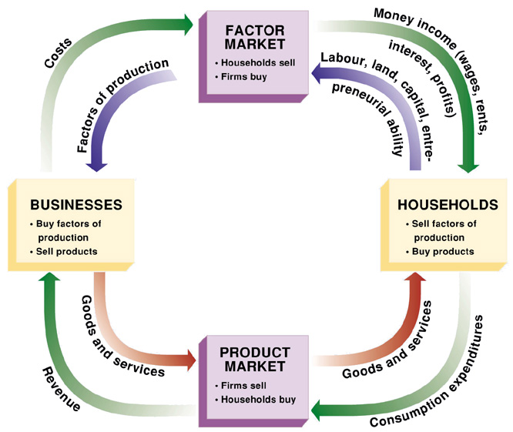

Government

* **Household** – Person/group of people living in a residence (not always a family)
  + **Consumers** use the final goods & services (outputs) to **satisfy wants & needs (utility)**
  + Consumers do the **demanding** in a market economy
* **Firm** – business organization that uses resources to produce goods/services, which it then sells
  + **Suppliers** transform **“inputs”** (F.O.P.) into **“outputs”** (products)
  + Producers do the **supplying** in a market economy
* **Factor/Resource Market** – markets where resources (F.O.P) are bought & sold
  + **Households are sellers of inputs (F.O.P.) & Firms are the buyers**
* **Labor** - Firms hire workers & pay them salaries called **wages**
* **Land** - Earn income from **rent**
* **Capital** - Earn **interest**
* **Entrepreneurship** – earn **profits**
* **Product Markets** – Households & firms interact; producers sell their goods & services to consumers
  + **Households are buyers** & **Firms are sellers** of outputs

**Money** serves as the **MEDIUM of EXCHANGE** in a Market Economy & these transactions take place between producers and consumers through non-fraudulent **voluntary exchange** to seek mutual benefits.

.