Hiram Elementary School Title I Family Engagement Annual Evaluation Summary
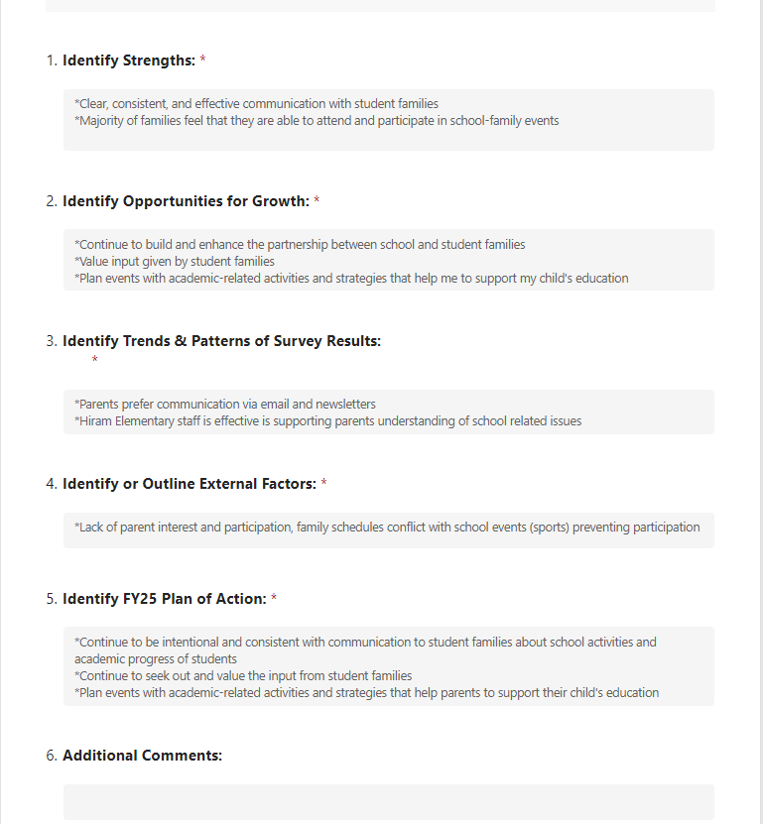
5-6-24

