  - Setember  This Week 09/28– 10/02  I hope everyone had a restful Fall Break. We will continue STEM all year. We began our 1st book for the year “Death by Toilet Paper”. In math we are working on solving two step equations with integers. We begin combining like terms to create two step equations to solve. We are learning about the three states of matter (solid, liquid and gas) in Science. We are working on properties of matter as well. *See vocabulary list below* This week we have lots of fun labs planned so we will be reviewing lab safety as well. In social studies we are working on economy (market, command and traditional). We are continuing to work on the same thing from before break just to make sure that we did not forget anything during our time apart.  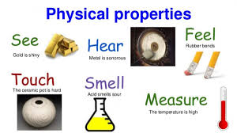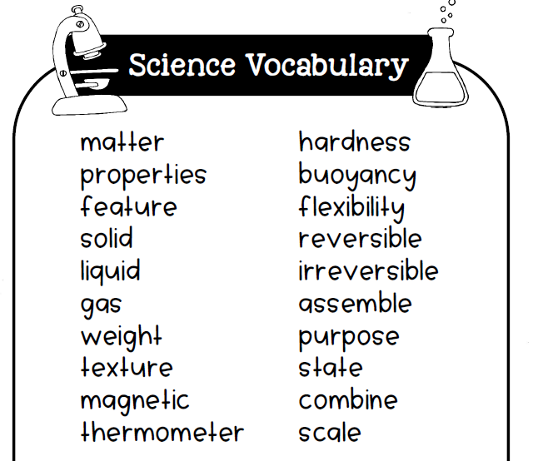  Email: knunn@paulding.k12.ga.us  Phone: 770-443-1449 |  |   Mrs. Nunn’s Class  Upcoming events  10/01 – Picture day  10/14 – 10/18 -2 hour early release (all week) Conference week (Details to come)  Questions to ask your child…  Which properties can be observed, and which ones need to be tested?  Play “I spy” with your child.  Name 2 characters in “Death by Toilet Paper”?  What is A letter used to represent an unknown number?  What is STEM?

